# Code:

<!DOCTYPE html>

<html>

<head>

<meta charset="UTF-8" />

<title>title</title>

<style>

h1{

text-align: center; color:darkred;

}

body{

background-image: url('../717821F216/lib2.jpg'); height: 100%;

background-position: center; background-repeat: no-repeat; background-size: cover;

}

form

{

text-align: center;

}

p{

color:aliceblue;

}

</style>

</head>

<body>

<form>

<h1>Libary management</h1><br>

<p>

<label for="t1">Enter The Title</label>

<input type="text" name="title" id="t1" placeholder="Type The Title">

</p>

<p>

<label for="a1">Enter The Author</label>

<input type="text" name="Author" id="a1" placeholder="Type The Author

">

</p>

<p>

<label for="yp1">Enter The yearPublished</label>

<input type="date" name="Published" id="yp1">

</p>

<p>

<label for="rs1">readStatus</label>

<input type="radio" name="readst" id="rs1">

<label for="rs1">Completed</label>

<input type="radio" name="readst" id="rs2">

<label for="rs2">InCompleted</label>

</p>

<p>

<button type="submit">Submit</button>

<button type="button" onclick="print()">Click</button>

<button type="button" onclick="addbook()">AddBook</button>

<button type="button" onclick="removebook()">Rmolabo</button>

<button type="button" onclick="abbbookFirst()">AddFir</button>

<button type="button" onclick="removeFirBook()">rmofir</button>

</p>

</form>

<script > function print(){ let Book={

title:document.getElementById('t1').value, author:document.getElementById('a1').value, yearPublished:document.getElementById('yp1').value, readStatus:true,

getSummary()

{

console.log("Title: "+this.title); console.log("Author: "+this.author); console.log("yearPublished: "+this.yearPublished); console.log("ReadStatus: "+this.readStatus);

}

}

Book.getSummary(); return Book;

}

let bka=new Array(); function addbook()

{

let ad=print(); bka.push(ad);

console.log("After Adding newBook"); console.log(bka);

}

function removebook()

{

bka.pop();

console.log("After Remove The Last Book"); console.log(bka);

}

function abbbookFirst()

{

let ac=print(); bka.unshift(ac);

console.log("After Adding book"); console.log(bka);

}

function removeFirBook()

{

bka.shift();

console.log("After Removing First Book"); console.log(bka);

}

</script>

</body>

</html>

# Output:



**Add Book In First:**

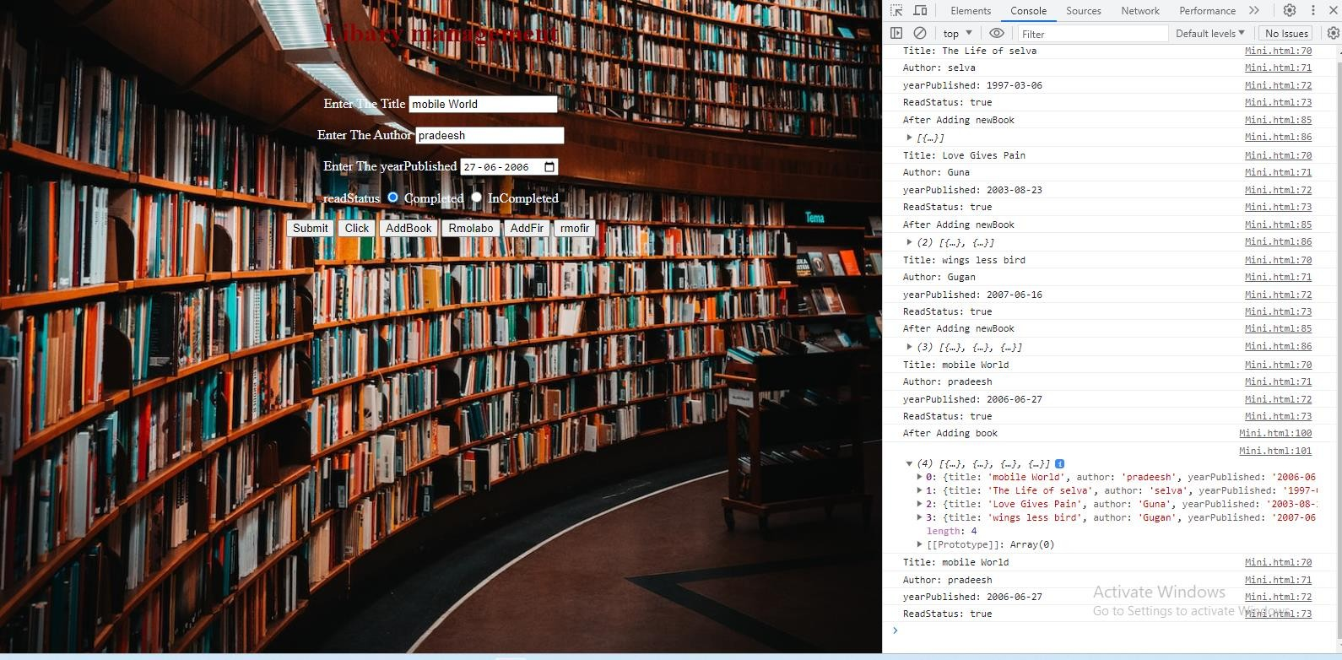

**Remove Last Book:**

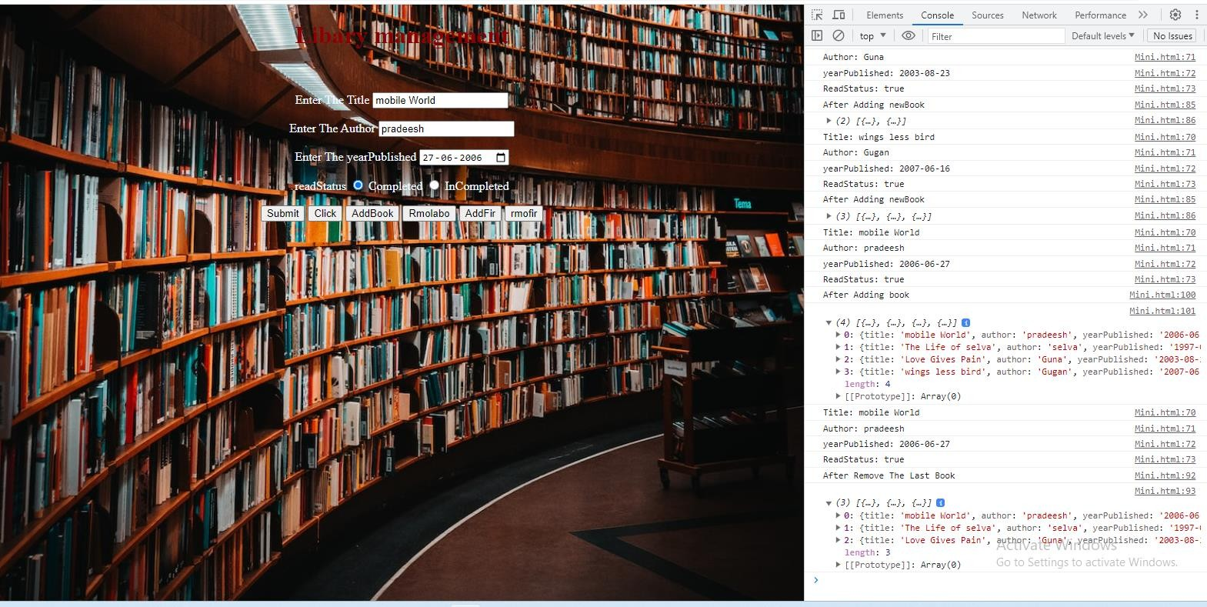

**Add Book In First :**

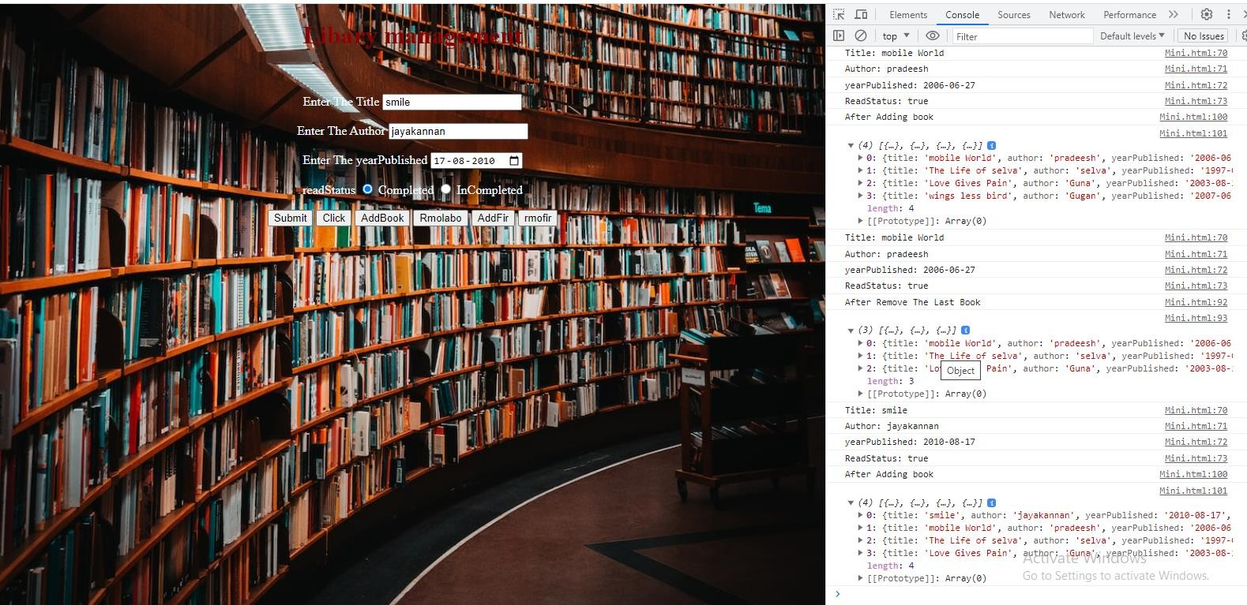

**Remove First Book:**

